|  |  |
| --- | --- |
|  | ***Review*** |

Answer the following questions, if you’re not sure or even don’t remember, revisit our videos, refer to our book or ask your instructors or your TAs:

Remember that there isn’t only one right answer, only good ones :)

* Why should we use functions at all?

So we can later call it and re-use it for another purpose

* How to define/declare a function?

Any code that can:

* Produce No errors
* Scalable
* Modular
* How to call/use a function?

Calling the correct name of the functions and ALL of its parameters.

* What is return, why and how do we use it?

Any output within a function that we want to keep/use its value

Use it by return the value within the function, and retrieve it by assigning a variable to the fuction’s name .

* Do we have to use return in **every** function?

No, some functions we can just call it to show results

* What are function arguments/parameters, why and how we use it?

See above

* How to use function from a different file other than our currently working file?

Put it in same folder or in a public library

Note: Function **arguments** are sometimes **also** called function **parameters**

Reference:

* [How to think like a computer scientist](http://www.ict.ru.ac.za/Resources/cspw/thinkcspy3/thinkcspy3.pdf), chapter 4
* [Python cheat sheet](https://www.dropbox.com/s/qgws0sammkb6fi6/1.%20beginners_python_cheat_sheet_pcc_all.pdf?dl=0)

|  |  |
| --- | --- |
| *http://www.bestappsforkids.com/wp-content/uploads/2012/04/save-turtle.png* | ***Turtle exercise*** |

1. Write a function that prints out “Hello world” 3 times (note: no arguments, no return)
2. Write a function that takes **2 numbers as arguments** and print out sum of them (note: has arguments, no return)
3. Write a Python function that **draws a square**, named draw_square, takes **2 arguments**: length and color, where length is the length of its side and color is the color of its bound (line color)
4. Now, another programmer named ‘T.Anh’ will use your code in exercise 1. He writes as follows:

**for** i **in** range(30):  
 **draw_square**(i * 5, **'red'**)  
 left(17)  
 penup()  
 forward(i * 2)  
 pendown()

Copy this code into your editor, run the whole program and see what it draws:

*Note: If your code does not run, try not to modify* T.Anh*’s code, modify your function instead*

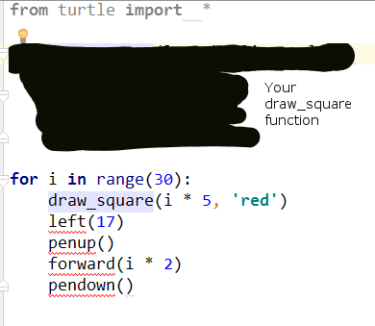

1. Write a Python function that draws a star, named draw_star, take 3 parameters: x, y, and length. Where x, y are the location of the star, length is the length of its side

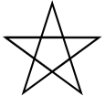

*Hint: Turn 144 degree at each point, Google ‘python 3 turtle go to position’*

1. Again, your function will be used by other programmers, they write as follows:

speed(0)  
color(**'blue'**)  
**for** i **in** range(100):  
 **import** random  
 x = random.randint(-300, 300)  
 y = random.randint(-300, 300)  
 length = random.randint(3, 10)  
 draw_star(x, y, length)

Copy this code into your editor, run the whole program and see what it draws:

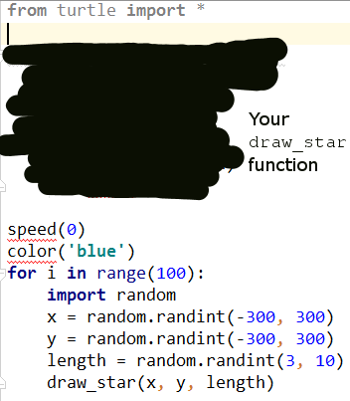

|  |  |
| --- | --- |
| http://images.8tracks.com/cover/i/001/358/131/7357.original-3735.jpg?rect=0,29,289,289&q=98&fm=jpg&fit=max&w=100&h=100 | ***Serious exercise*** |

1. Write a function that removes the dollar sign (“$”) in a string, named remove_dollar_sign, takes 1 arguments: s, where s is the input string, **returns** the new string with no dollar sign in it

*Hint: Google “Python string replace remove”*

1. Now, another programmer named Hiep will use your code in exercise 3. He writes as follows:

string_with_no_dollars = remove_dollar_sign(**"$80% percent of $life is to show $up"**)  
**if** string_with_no_dollars == **"80% percent of life is to show up"**:  
 print(**"Your function is correct"**)  
**else**:  
 print(**"Oops, there's a bug"**)

Copy this code into your editor, run the whole program and see what it prints out:

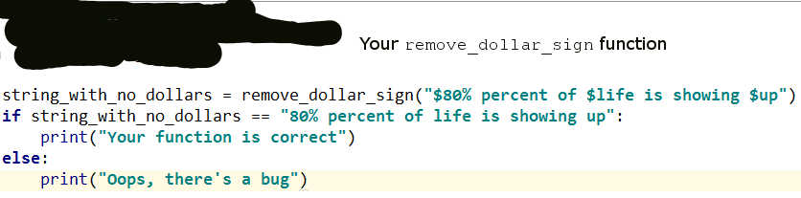

If it prints out **“Your function is correct”**, we’re good

If it prints out **“Oops, there’s a bug”**, you might want to come back and check your function

1. Write a function that extracts the even items in a given integer list, named get_even_list, takes 1 parameter: l, where l is the given integer list ([1, 4, 5, -1, 10] for example), returns a new list contains only even numbers ([4, 10] if the given list is [1,4,5,-1,10])
2. Let’s take your function to the test. The tester will write his/her test code as follows:

even_list = get_even_list([1, 2, 5, -10, 9, 6])  
  
**if** set(even_list) == set([2, -10, 6]):  
 print(**"Your function is correct"**)  
**else**:  
 print(**"Ooops, bugs detected"**)

Copy this code into your editor, run the whole program and see what it prints out:

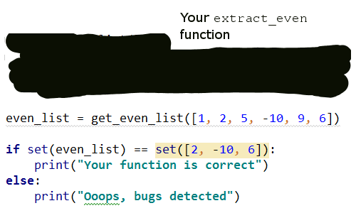

If it prints out **“Your function is correct”**, we’re good

If it prints out **“Oops, bugs detected”**, you might want to come back and check your function

*Note:* ***set*** *is an unordered data structure, meaning set of (1, 2,3) equals set of (3, 1, 2)*

1. Write a function named is_inside that checks if a point is inside a rectangle, takes 2 parameters, the first is a list with 2 elements respectively represents x and y coordinates of the given point, the second is a list with 4 elements respectively represents x, y coordinates and width height of the given rectangle

For example:

is_inside([100, 120], [140, 60, 100, 200])

should return False

**140**

**60**

**width = 100**

**height = 200**

X

Y

**120**

**100**

and

is_inside([200, 120], [140, 60, 100, 200])

should return True

**140**

**60**

**width = 100**

**height = 200**

X

Y

**120**

**200**

1. (**Optional**) Write test cases (as we did in exercices 8 and 10) to check if your is_inside function is correct

12. (**Optional**) Download [this starter code](https://drive.google.com/open?id=1MmTXikygr4_IStHwySGYXYmdDSYI3TJE) and unzip it. Inside you will find the BackColor Game with UI and without core logic.

You can try running it by typing “python app.py”.

Now Open file backcolor.py and have a look at the shapes data structure, what type of data is this, dictionary, list or both?

If you don’t know what ‘#C62828’ is, scroll to the last page

Inside an item of shapes is the information about a colored rectangle drawn in the UI:

(Note: the **text** is not shown here but in the quiz)

**#C62828**

**x = 140**

**y = 60**

**width = 100**

**height = 100**

X

Y

Your job is to write the generate_quiz and mouse_press (though you can play a little bit, but you SHOULD NOT touch get_shapes() function) to serve the following functionality:

generate_quiz()

Each time the UI developer wants to generate quiz, she will call generate_quiz and expect a list in return, this list, must contain 3 elements (in this order):

text: The text to be shown to users

color: The color of the shown text

quiz_type:

**0** if users must select one the rectangles by the **Meaning** of the text as the answer

**1** if users must select one the rectangles by the **Color** of the text as the answer

mouse_press()

Each time users click on the screen, the UI developer will call mouse_press to check if users have just answered correctly

x, y: The coordinates of the position that users have just clicked

text: The Quiz’s text being shown to users

color: The Quiz’s color being shown to users

quiz_type: The current Quiz Type - users should select by Meaning or the Color of the Text

The return value must be True or False, which represents users’ correctness

To understand the functions’ arguments better, you should print them out, run and play with the UI before go for the coding

#C62828 is hex color, Google: “color picker” and try to move the sidebar left and right:

Drag this left and right